Name: Date: u-e words 2

The long (u) sound is usually represented by the u-e pattern when it comes in the middle of words, like in the words below.

Remember: Say the word aloud, then say each letter aloud as you write it e.g. 'acute, a ... c ... u ... t ... e'
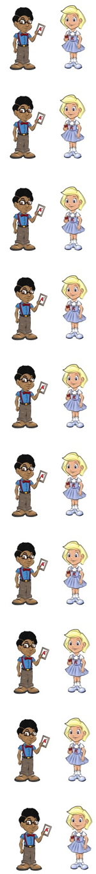
An acute angle is smaller than a right angle.

Perfume (per/fume) makes a woman smell nice.

A fortune (for/tune) means a lot of money.

To accuse (ac/cuse) someone means to say they did the wrong thing.

An obtuse (ob/tuse) angle is between 91 and 179 degrees.

Volume (vol/ume) means how loud it is.

If you abuse (ab/use) someone you are not nice to them.

If you amuse (am/use) someone you make them laugh.

A costume (cos/tume) is a set of clothes.

A module (mo/dule) is a small part of a course.

Now test yourself without looking at the words and check for yourself if you got them all right. Practice writing any words that you made mistakes on again.

© www.SaveTeachersSundays.com 2013

Name: Date: u-e words 2

The long (u) sound is usually represented by the u-e pattern when it comes in the middle of words, like in the words below.

Remember: Say the word aloud, then say each letter aloud as you write it e.g. 'acute, a ... c ... u ... t ... e'

Try to spell each word without looking at it.

An angle is smaller than a right angle.

makes a woman smell nice.

A means a lot of money.

To someone means to say they did the wrong thing.

An angle is between 91 and 179 degrees.

means how loud it is.

If you someone you are not nice to them.

If you someone you make them laugh.

A is a set of clothes.

A is a small part of a course.

Now check for yourself if you got them all right. Practice writing any words that you made mistakes on again.

© www.SaveTeachersSundays.com 2013

